**Lab 9**

Use two images for each operation to do the following operations and write down their advantages and disadvantages and explain your results:

1. **Roberts(****headCT_Vandy.pgm, building_original.pgm, noisy_fingerprint.pgm):**

**Algorithm:**

* 1. Calculate the gradient of the image by using the selected operator template;
  2. Select an appropriate threshold and judge the gradient value of the image point by point. All points that meet g (x, y) > t are taken as 255, and other points are taken as 0. Thus, the edge image of the image to be tested is obtained.

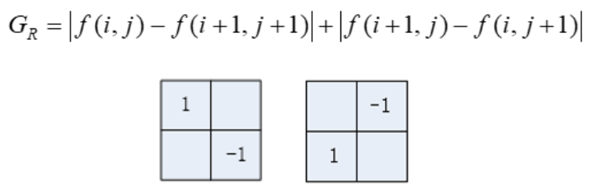

**Results (including pictures):**

Source:

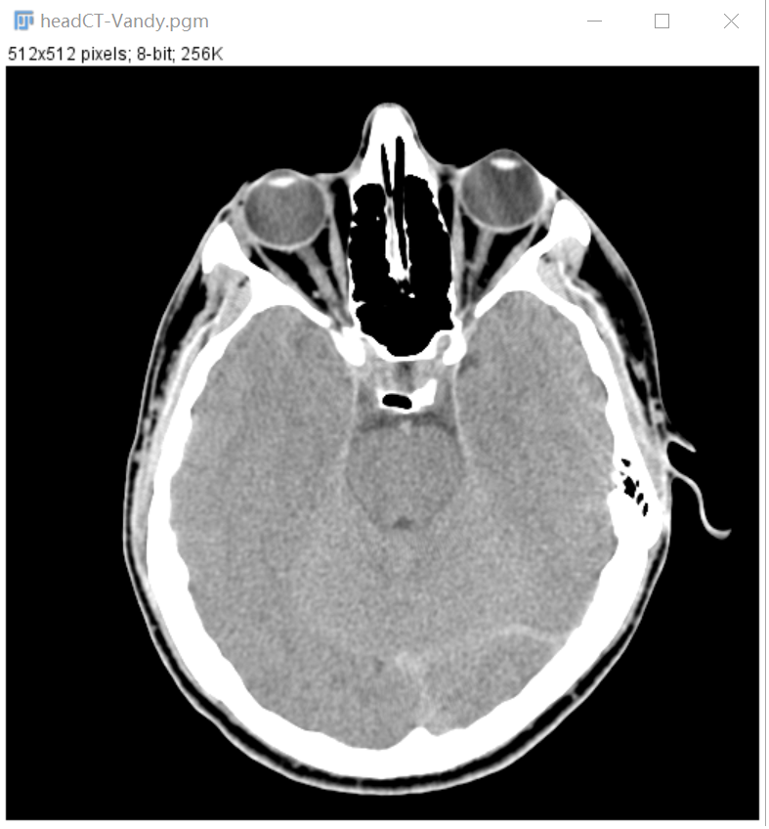

result:

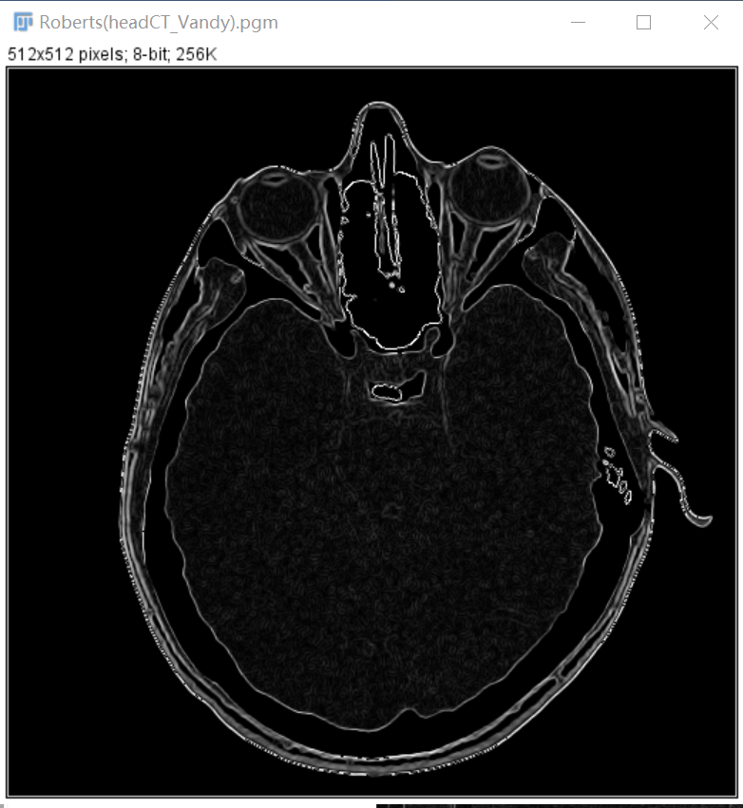

Source:

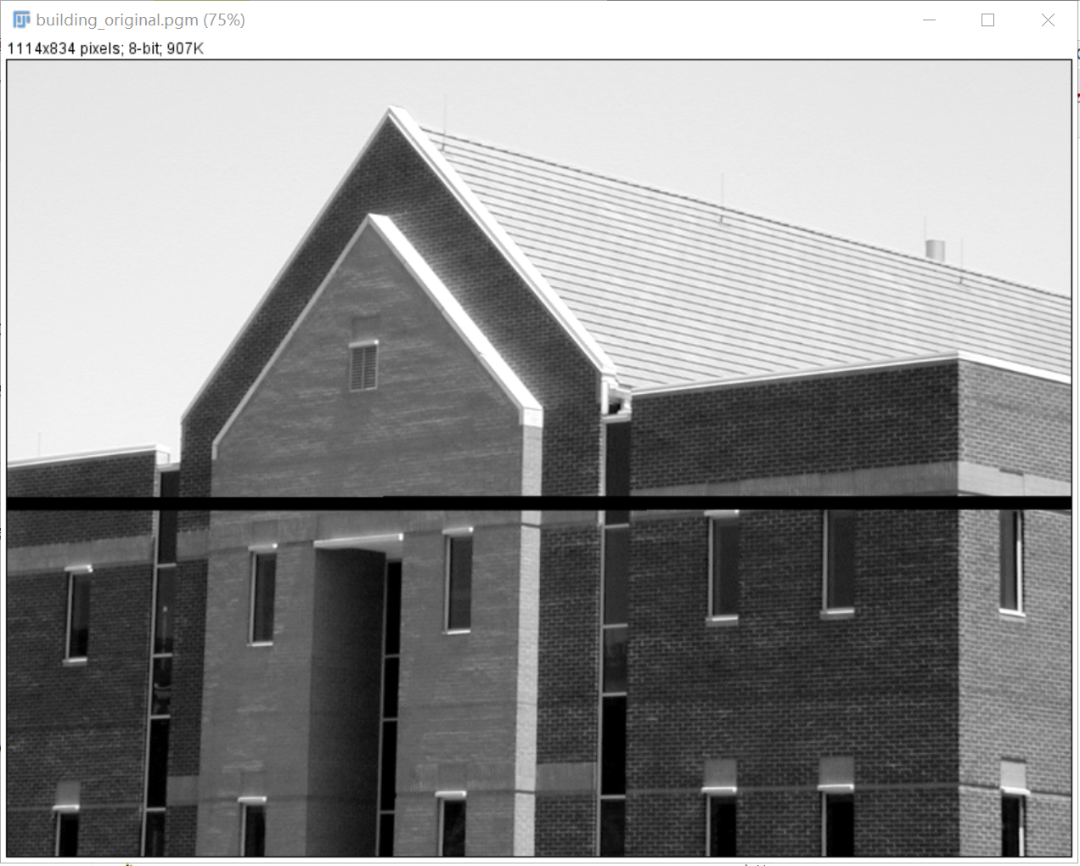

Result:

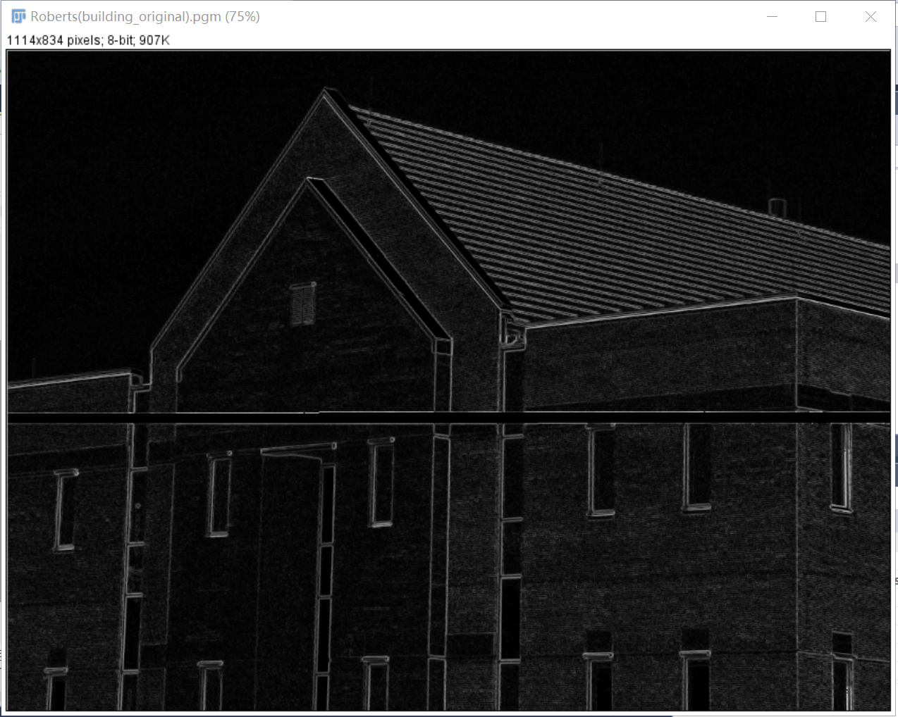

Source: Result:

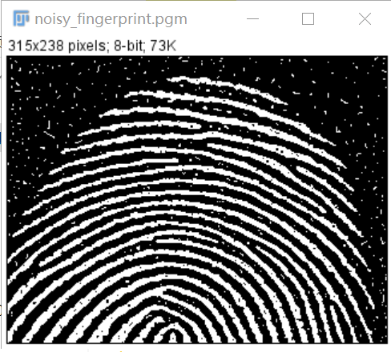 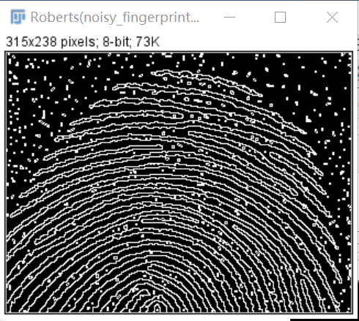

**Discussion:**

Roberts operator is the simplest operator. It is an operator that uses local difference operator to find the edge.

It uses the difference between two adjacent pixels in the diagonal direction to approximate the gradient amplitude to detect the edge.

The effect of detecting vertical edge is better than oblique edge, with high positioning accuracy, sensitive to noise and unable to suppress the influence of noise.

It seems that the effect of Roberts operator is surprisingly good inheadCT_Vandy.pgm and building_original.pgm. Although it is the simplest operator, the effect is even better than other operators like Prewitt or Sobel operator.

**Codes:**

Image *Roberts(Image* image) {

int width, height;

width = image->Width;

height = image->Height;

Image* outimage;

unsigned char* tempin, *tempout;

const char* comment = "Roberts";

outimage = CreateNewImage(image, comment);

tempin = image->data;

tempout = outimage->data;

int x, y;

for (int i = 1; i < height-1; i++){

for (int j = 1; j < width - 1; j++){

tempout[i*width + j] = abs(tempin[i*width + j] - tempin[(i - 1)*width + j - 1]) + abs(tempin[i*width + j - 1] - tempin[(i - 1)*width + j]);

}

}return(outimage);

}

1. **Prewitt(headCT_Vandy.pgm, building_original.pgm, noisy_fingerprint.pgm):**

**Algorithm:**

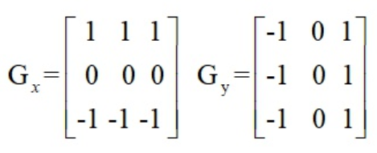

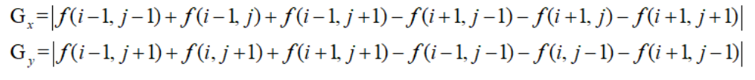



**Results (including pictures):**

Source:



result:

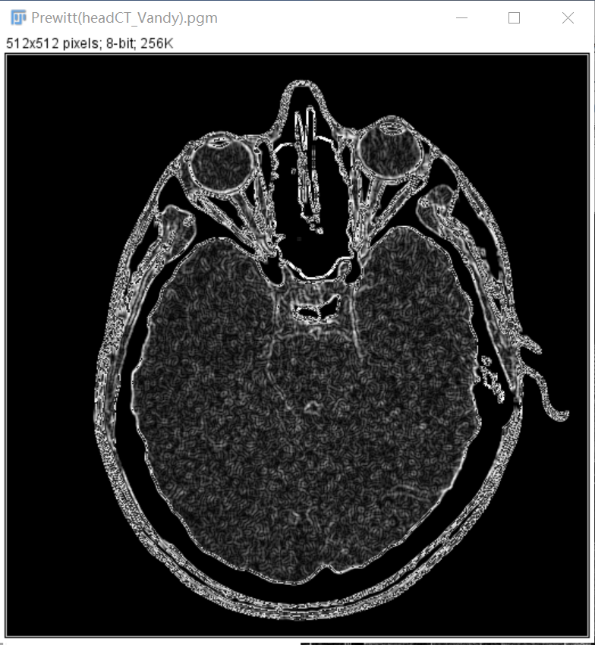

Source:



Result:

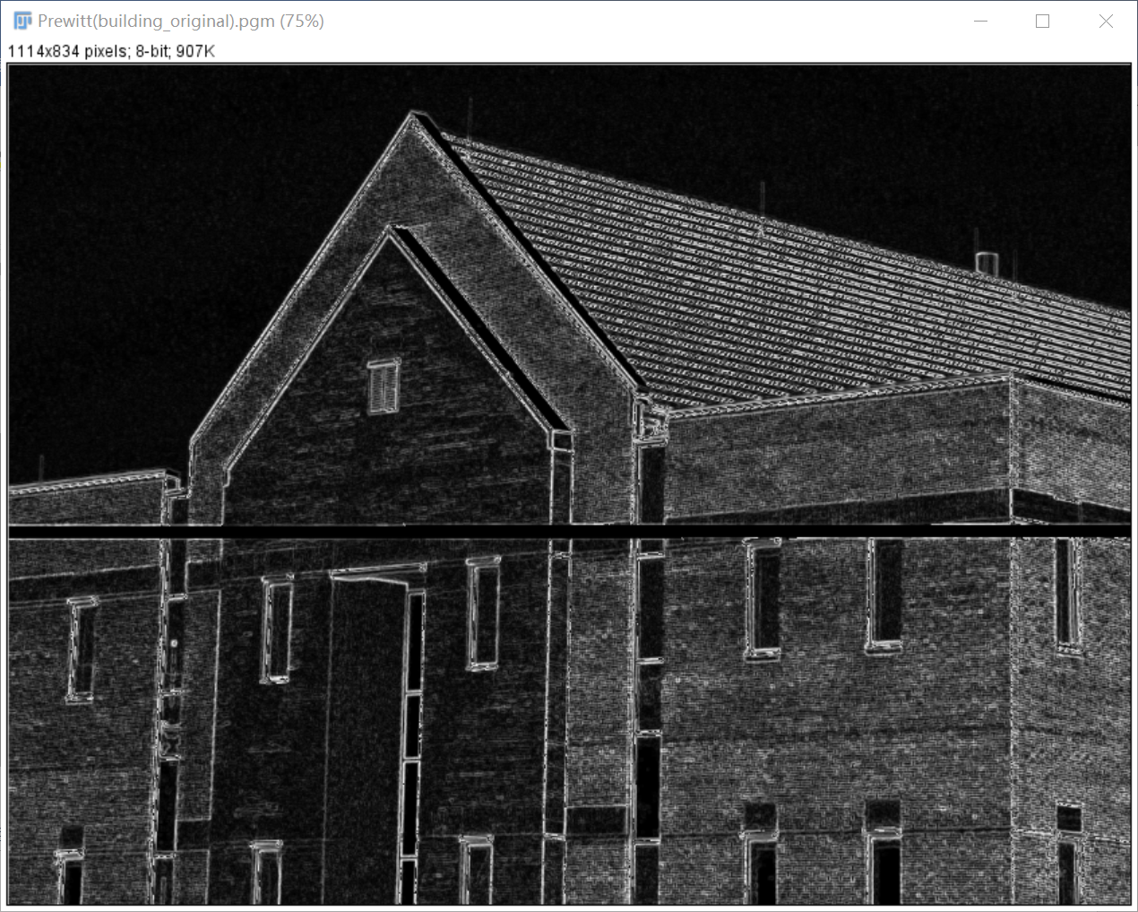

Source: Result:

 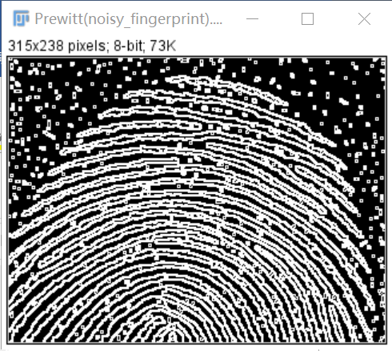

**Discussion:**

Prewitt operator differentiates in one direction and averages in the other direction, so it is relatively insensitive to noise and can suppress noise. However, pixel average is equivalent to low-pass filtering of the image, so Prewitt operator is not as good as Roberts operator in edge location.

**Codes:**

Image *Prewitt(Image* image) {

int width, height;

width = image->Width;

height = image->Height;

Image* outimage;

unsigned char* tempin, *tempout;

const char* comment = "Prewitt";

outimage = CreateNewImage(image, comment);

tempin = image->data;

tempout = outimage->data;

int x, y, flag;

for (int i = 1; i < height - 1; i++){

for (int j = 1; j < width - 1; j++){

tempout[i*width + j] = abs(tempin[(i - 1)*width + j - 1] + tempin[(i - 1)*width + j] + tempin[(i - 1)*width + j + 1] - (tempin[(i + 1)*width + j - 1] + tempin[(i + 1)*width + j] + tempin[(i + 1)*width + j + 1])) + abs(tempin[(i - 1)*width + j + 1] + tempin[i * width + j+1] + tempin[(i + 1)*width + j + 1] - (tempin[(i - 1)*width + j - 1] + tempin[i * width + j - 1] + tempin[(i + 1)*width + j - 1]));

}

}return(outimage);

}

1. **Sobel (headCT_Vandy.pgm, building_original.pgm, noisy_fingerprint.pgm):**

**Algorithm:**

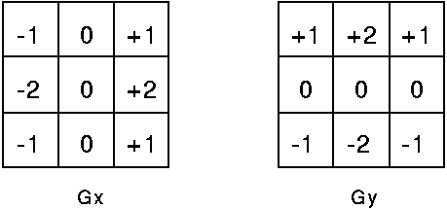

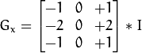



**Results (including pictures):**

Source:



result:

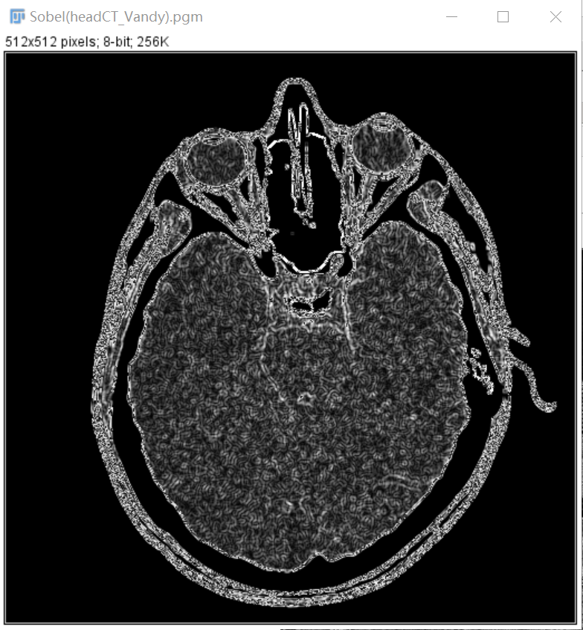

Source:



Result:

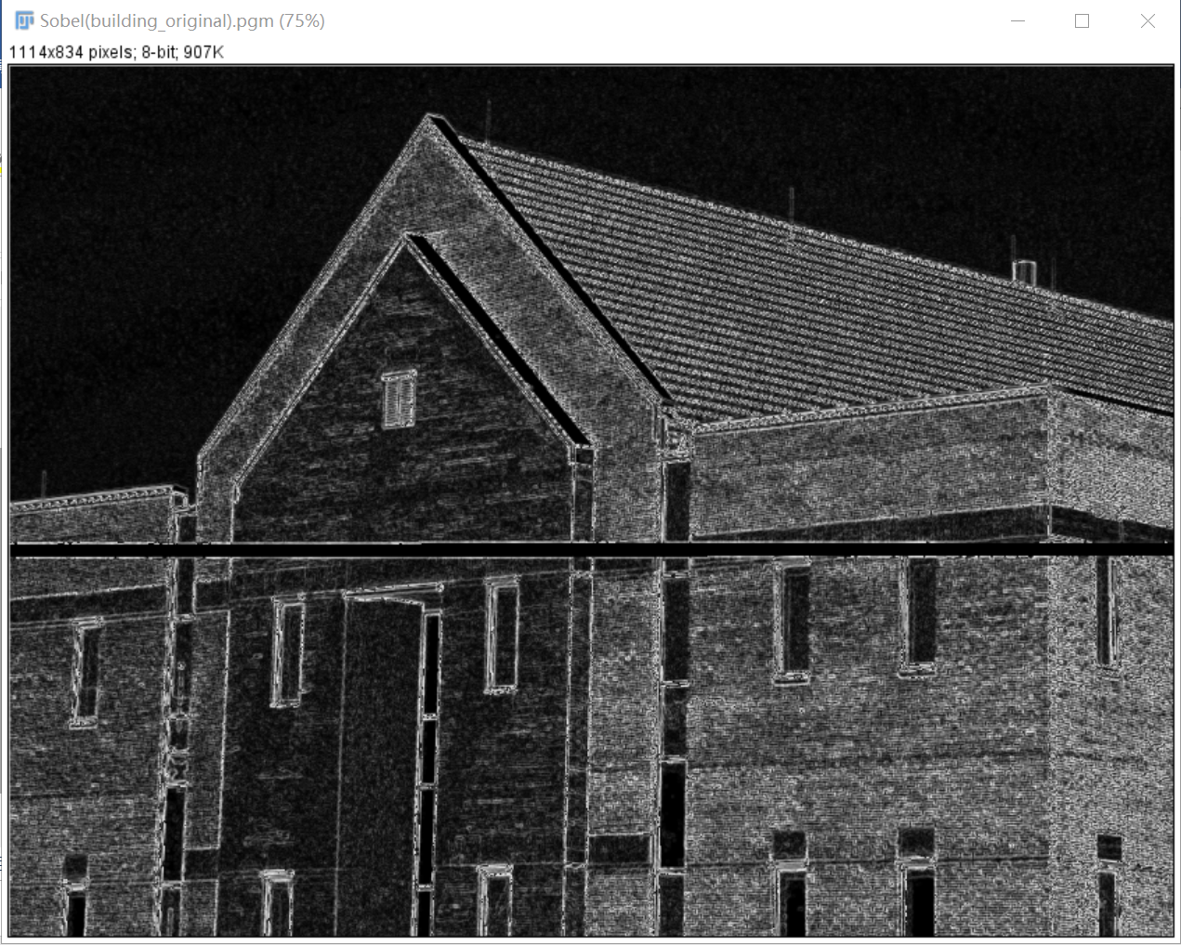

Source: Result:

 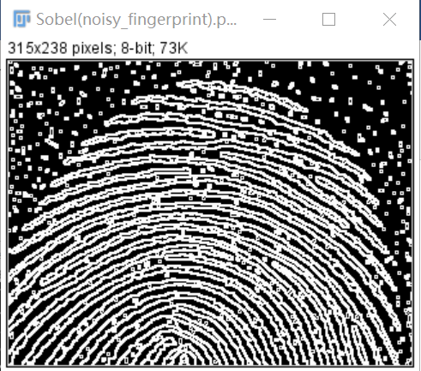

**Discussion:**

Sobel operator not only produces good detection effect, but also has smooth suppression effect on noise, but the obtained edge is thick and may appear pseudo edge.

**Codes:**

Image *Sobel(Image* image) {

int width, height;

width = image->Width;

height = image->Height;

Image* outimage;

unsigned char* tempin, *tempout;

const char* comment = "Sobel";

outimage = CreateNewImage(image, comment);

tempin = image->data;

tempout = outimage->data;

for (int i = 1; i < height - 1; i++){

for (int j = 1; j < width - 1; j++){

tempout[i*width + j] = abs(tempin[(i - 1)*width + j + 1] + 2 * tempin[i*width + j + 1] + tempin[(i + 1)*width + j + 1] - (tempin[(i - 1)*width + j - 1] + 2 * tempin[i*width + j - 1] + tempin[(i + 1)*width + j - 1])) + abs(tempin[(i + 1)*width + j - 1] + 2 * tempin[(i + 1)*width + j] + tempin[(i + 1)*width + j + 1] - (tempin[(i - 1)*width + j - 1] + 2 * tempin[(i - 1)*width + j] + tempin[(i - 1)*width + j + 1]));

}

}return(outimage);

}

1. **canny edge detection (headCT_Vandy.pgm, building_original.pgm):**

**Algorithm:**

Step 1: Smooth input image with a Gaussian filter (remove noise).

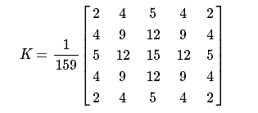

Step 2: Compute the gradient magnitude and angle image.

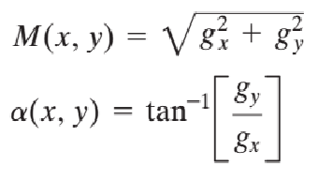

Step3: Apply nonmaxima suppression to the gradient magnitude image

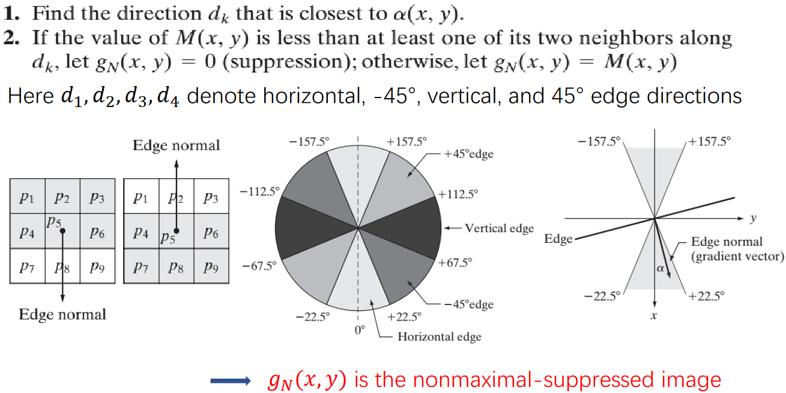

Step4: Use double thresholding and connectivity analysis to detect and link edges

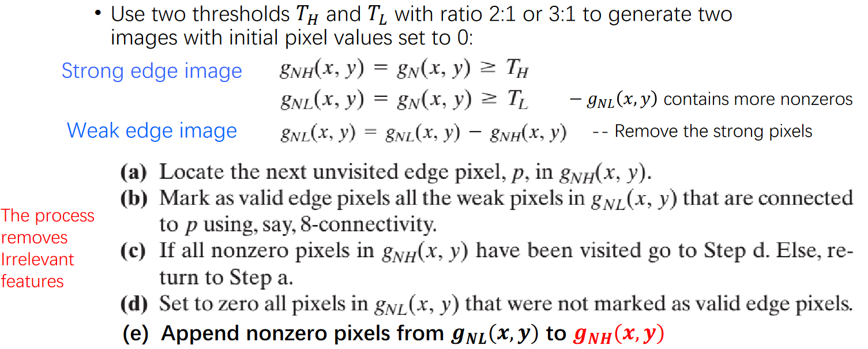

**Results (including pictures):**

Source:



Result(Gaussian):

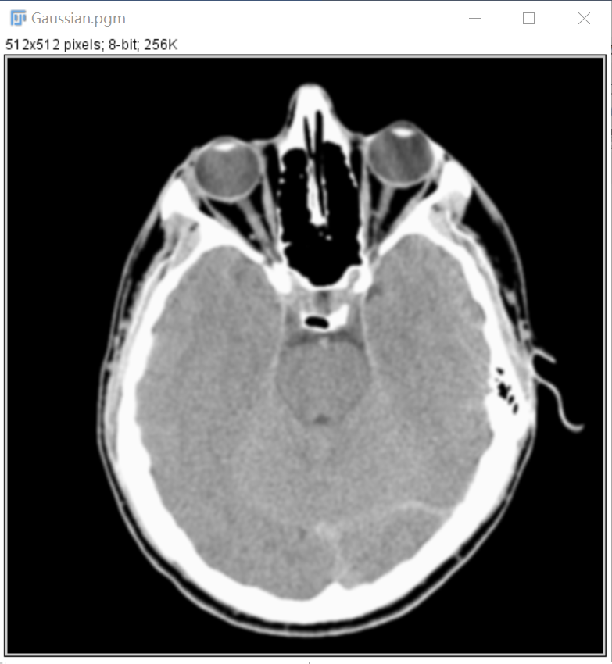

Result(Sobel):

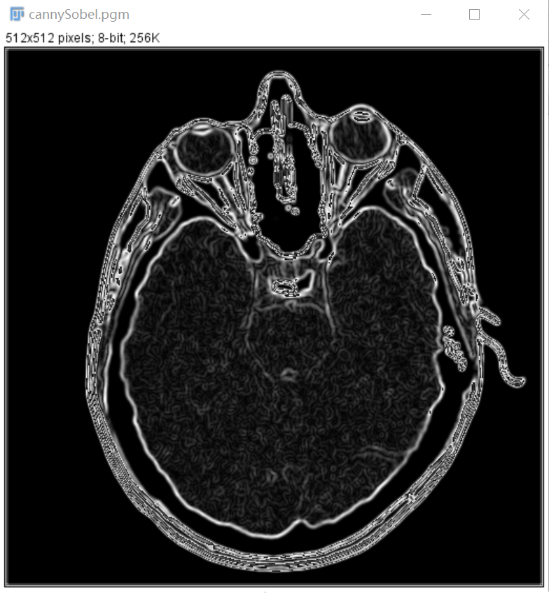

Result(nonmaxima suppression):

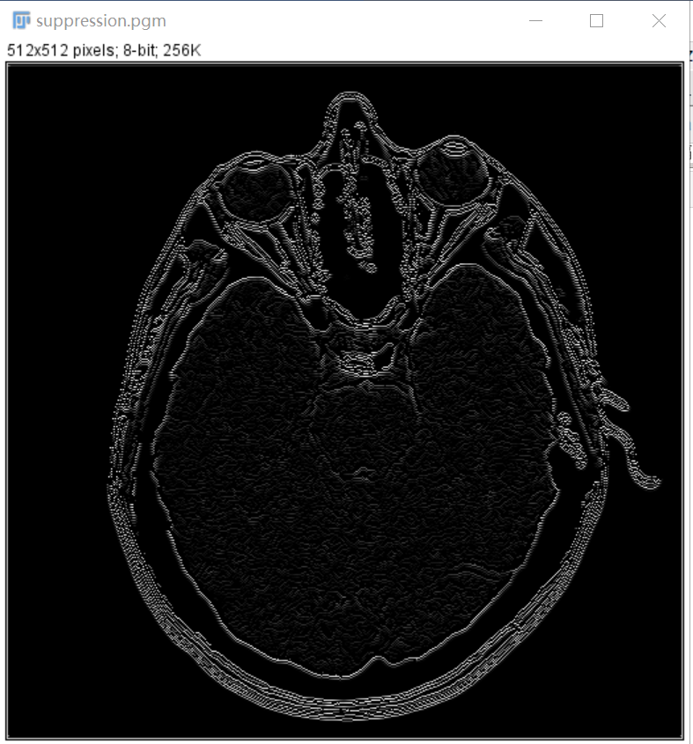

Result(double thresholding):

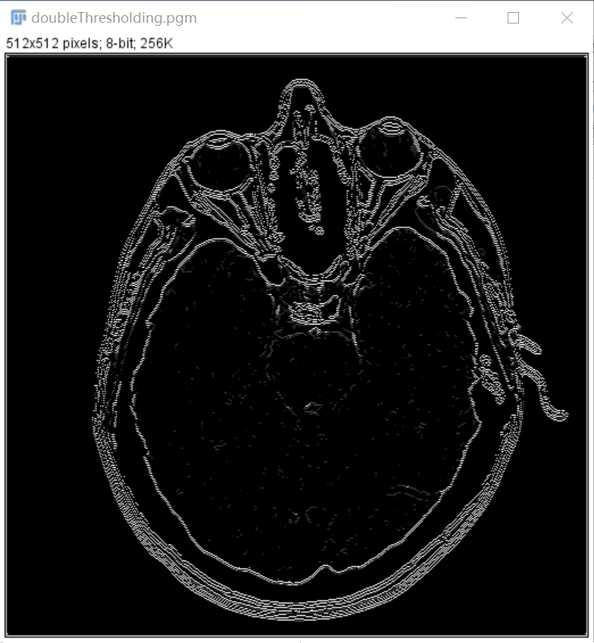

Result(Canny):

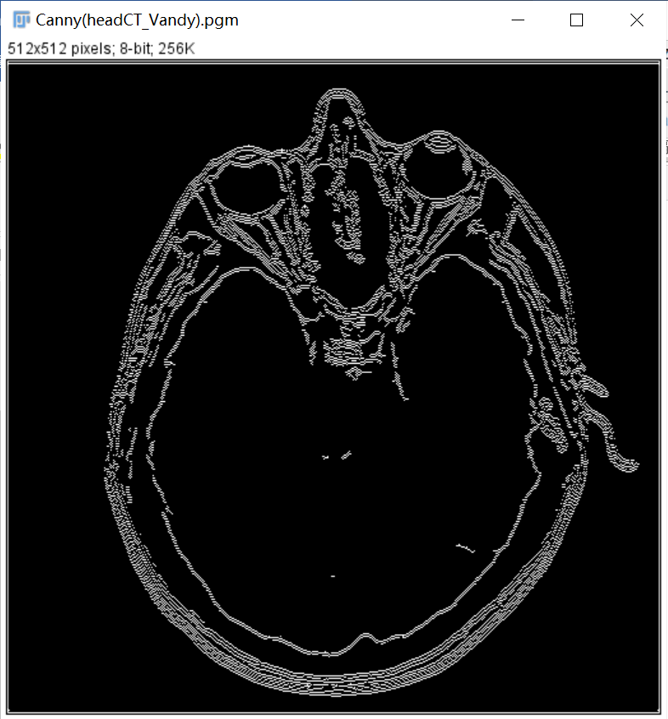

Source:



Result(Gaussian):

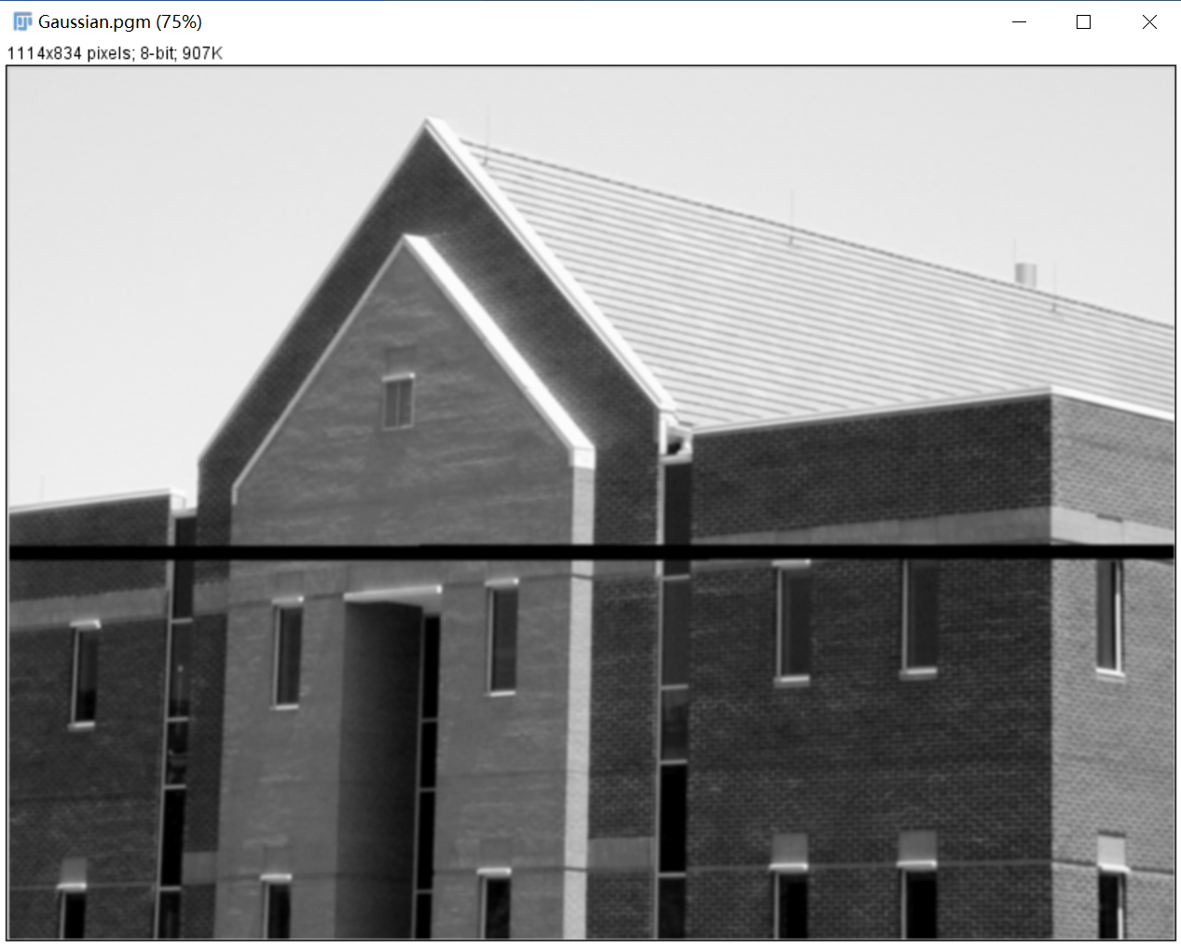

Result(Sobel):

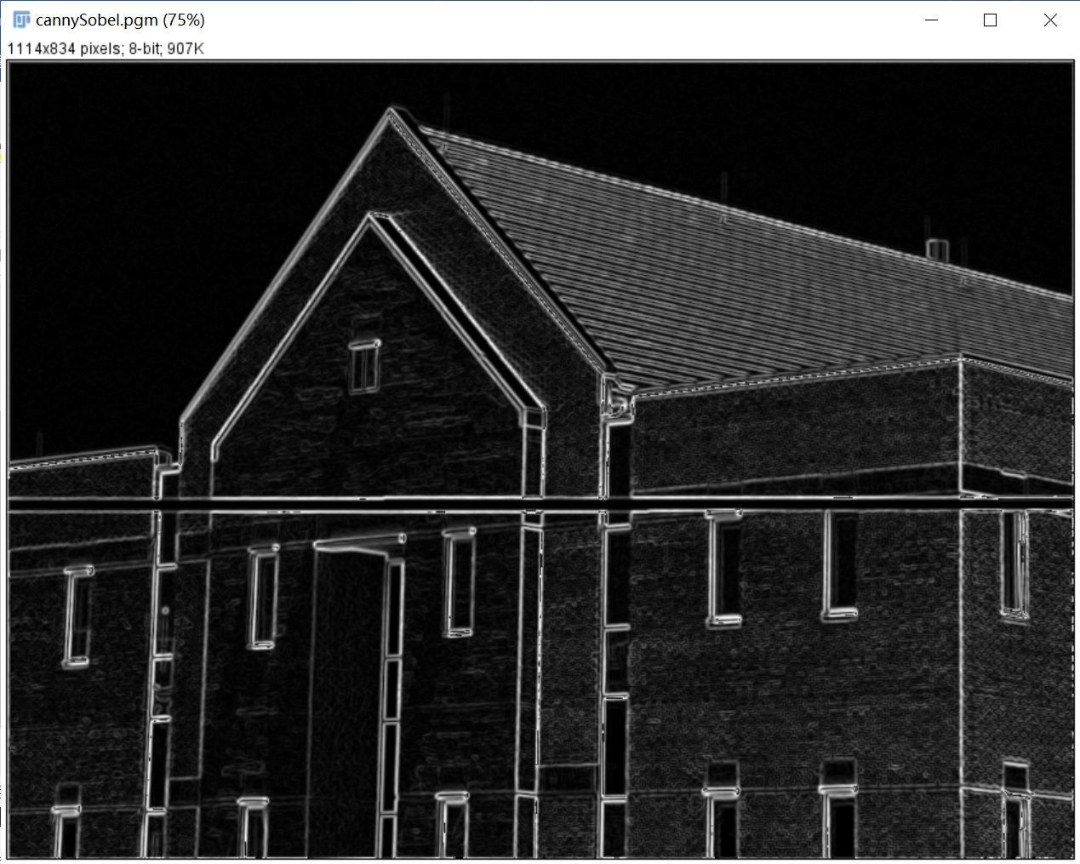

Result(nonmaxima suppression):

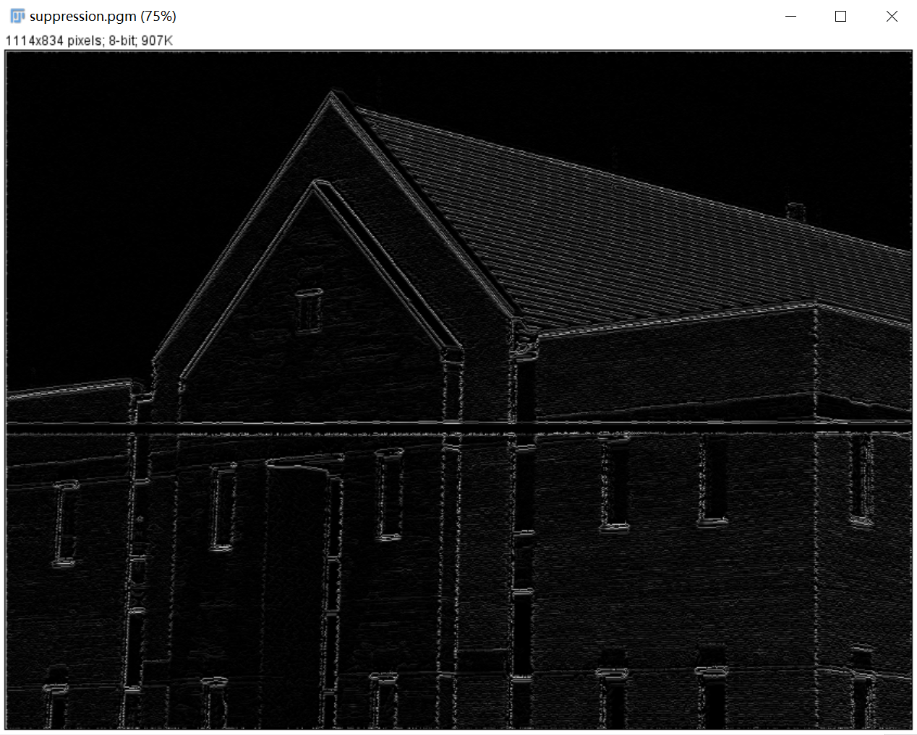

Result(double thresholding):

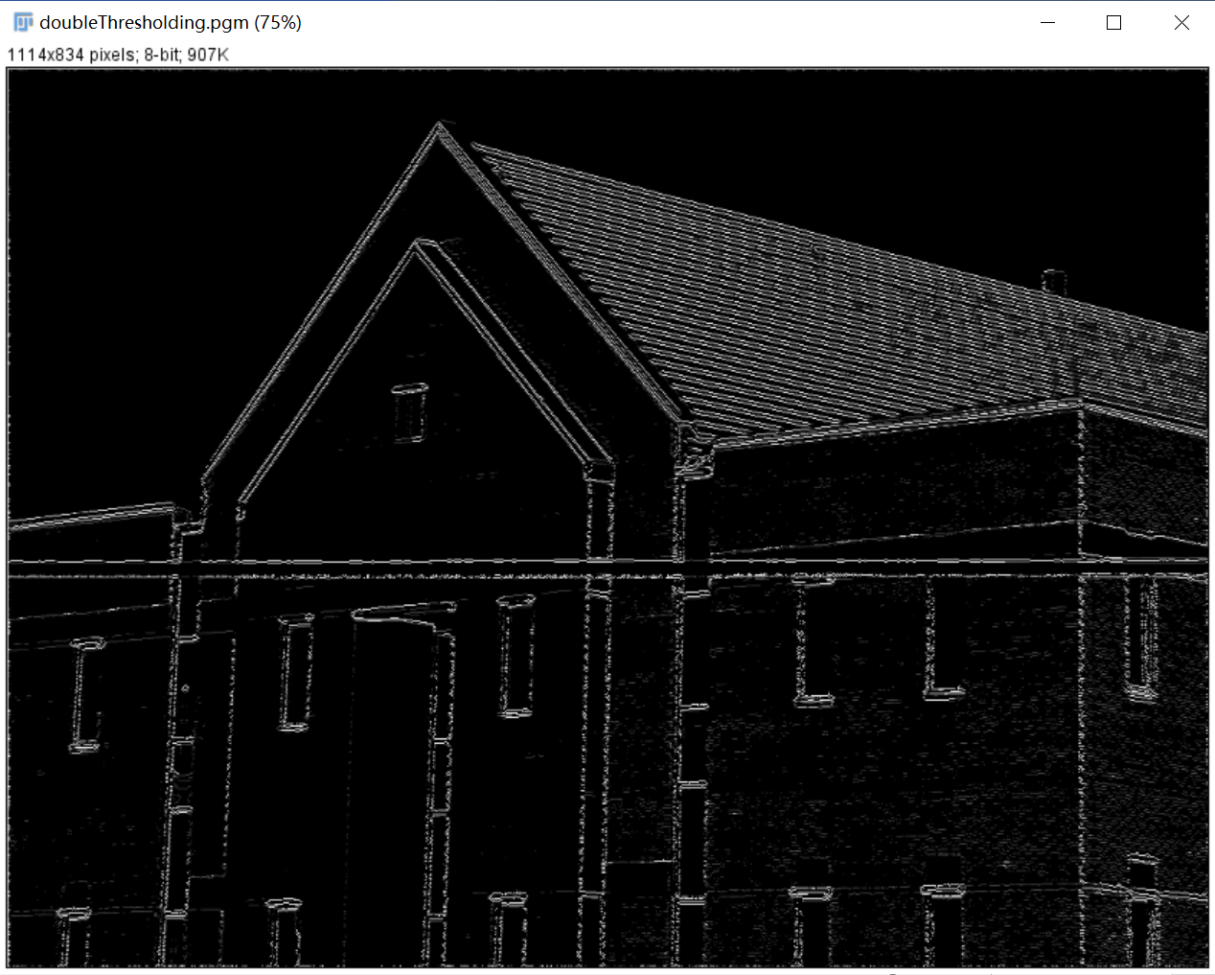

Result(Canny):

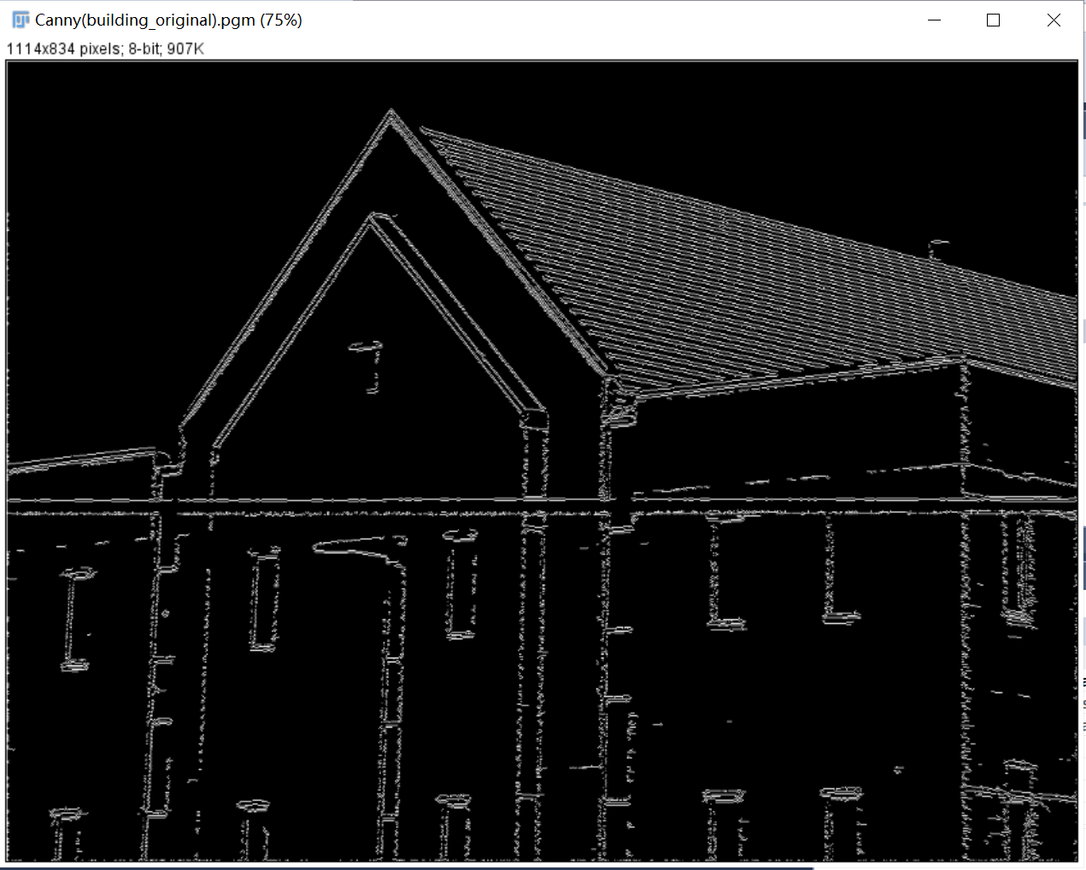

**Discussion:**

Whatever in headCT_Vandy.pgm or noisy_fingerprint.pgm, The edge doesn't seem to be well extracted and the effect is not as good as in the textbook. I cannot figure out what’s wrong and I’m sure I didn’t make mistakes about the principle. Maybe the problem is that some values in the array are out of the correct range.

**Codes:**

Image *Canny(Image* image) {

int width, height;

width = image->Width;

height = image->Height;

Image* outimage;

unsigned char* tempin, *tempout;

const char* comment = "Canny";

outimage = CreateNewImage(image, comment);

tempin = image->data;

tempout = outimage->data;

double pi = acos((double)-1);

Image* GaussianImage;

unsigned char* Gaussian;

GaussianImage = CreateNewImage(image, comment);

Gaussian = GaussianImage->data;

for (int i = 2; i < height - 2; i++){

for (int j = 2; j < width - 2; j++){

Gaussian[i*width + j] = (2 * tempin[(i - 2)*width + j - 2] + 4 * tempin[(i - 2)*width + j - 1] + 5 * tempin[(i - 2)*width + j] + 4 * tempin[(i - 2)*width + j + 1] + tempin[(i - 2)*width + j + 2]

+ 4 * tempin[(i - 1)*width + j - 2] + 9 * tempin[(i - 1)*width + j - 1] + 12 * tempin[(i - 1)*width + j] + 9 * tempin[(i - 1)*width + j + 1] + 4 * tempin[(i - 1)*width + j + 2]

+ 5 * tempin[i*width + j - 2] + 12 * tempin[i*width + j - 1] + 15 * tempin[i*width + j] + 12 * tempin[i*width + j + 1] + 5 * tempin[i*width + j + 2]

+ 4 * tempin[(i + 1)*width + j - 2] + 9 * tempin[(i + 1)*width + j - 1] + 12 * tempin[(i + 1)*width + j] + 9 * tempin[(i + 1)*width + j + 1] + 4 * tempin[(i + 1)*width + j + 2]

+ 2 * tempin[(i + 2)*width + j - 2] + 4 * tempin[(i + 2)*width + j - 1] + 5 * tempin[(i + 2)*width + j] + 4 * tempin[(i + 2)*width + j + 1] + tempin[(i + 2)*width + j + 2]) / 159;

}

}

SavePNMImage(GaussianImage, "..\\output\\Gaussian.pgm");

Image* SobelImage;

unsigned char* gradient;

SobelImage = CreateNewImage(image, comment);

gradient = SobelImage->data;

for (int i = 1; i < height - 1; i++){

for (int j = 1; j < width - 1; j++){

gradient[i*width + j] = sqrt(pow((double)Gaussian[(i - 1)*width + j + 1] + 2 * Gaussian[i*width + j + 1] + Gaussian[(i + 1)*width + j + 1] - (Gaussian[(i - 1)*width + j - 1] + 2 * Gaussian[i*width + j - 1] + Gaussian[(i + 1)*width + j - 1]), 2)

+ pow((double)Gaussian[(i + 1)*width + j - 1] + 2 * Gaussian[(i + 1)*width + j] + Gaussian[(i + 1)*width + j + 1] - (Gaussian[(i - 1)*width + j - 1] + 2 * Gaussian[(i - 1)*width + j] + Gaussian[(i - 1)*width + j + 1]), 2));

}

}

SavePNMImage(SobelImage, "..\\output\\cannySobel.pgm");

unsigned char* angle;

angle = (unsigned char*)malloc(width*height);

for (int i = 1; i < height - 1; i++){

for (int j = 1; j < width - 1; j++){

angle[i*width + j] = atan2((float)Gaussian[(i - 1)*width + j + 1] + 2 * Gaussian[i*width + j + 1] + Gaussian[(i + 1)*width + j + 1] - (Gaussian[(i - 1)*width + j - 1] + 2 * Gaussian[i*width + j - 1] + Gaussian[(i + 1)*width + j - 1]),

Gaussian[(i + 1)*width + j - 1] + 2 * Gaussian[(i + 1)*width + j] + Gaussian[(i + 1)*width + j + 1] - (Gaussian[(i - 1)*width + j - 1] + 2 * Gaussian[(i - 1)*width + j] + Gaussian[(i - 1)*width + j + 1]))*180/pi;

}

}

Image* suppressionImage;

unsigned char* suppression;

suppressionImage = CreateNewImage(image, comment);

suppressionImage->data = SobelImage->data;

suppression = suppressionImage->data;

for (int i = 1; i < height - 1; i++){

for (int j = 1; j < width - 1; j++){

double g0, g1;

if (angle[i*width + j] >= -3 * pi / 8 && angle[i*width + j] < -pi / 8 && angle[i*width + j] < 7 * pi / 8 && angle[i*width + j] >= 5 * pi / 8){

g0 = gradient[(i - 1)*width + j - 1];

g1 = gradient[(i + 1)*width + j + 1];

}

else if (angle[i*width + j] >= -pi / 8 && angle[i*width + j] < pi / 8 && angle[i*width + j] > -7*pi / 8 && angle[i*width + j] <= 7*pi / 8){

g0 = gradient[i*width + j - 1];

g1 = gradient[i*width + j + 1];

}

else if (angle[i*width + j] >= pi / 8 && angle[i*width + j] < 3 * pi / 8 && angle[i*width + j] >= -7 * pi / 8 && angle[i*width + j] < 5 * pi / 8){

g0 = gradient[(i - 1)*width + j + 1];

g1 = gradient[(i + 1)*width + j - 1];

}

else{

g0 = gradient[(i - 1)*width + j];

g1 = gradient[(i + 1)*width + j];

}

if (gradient[i*width + j] <= g0 || gradient[i*width + j] <= g1) {

suppression[i*width + j] = 0;

}

}

}

SavePNMImage(suppressionImage, "..\\output\\suppression.pgm");

Image* doubleThresholdingLinkImage;

unsigned char* doubleThresholdingLink;

doubleThresholdingLinkImage = CreateNewImage(image, comment);

doubleThresholdingLinkImage->data = suppressionImage->data;

doubleThresholdingLink = doubleThresholdingLinkImage->data;

for (int i = 1; i < height ; i++) {

for (int j = 1; j < width - 1; j++) {

if (suppression[i*width + j] > 100) {

doubleThresholdingLink[i*width + j] = 255;

}

else if (suppression[i*width + j] < 50) {

doubleThresholdingLink[i*width + j] = 0;

}

}

}

SavePNMImage(doubleThresholdingLinkImage, "..\\output\\doubleThresholding.pgm");

for (int i = 1; i < height - 1; i++) {

for (int j = 1; j < width - 1; j++) {

if (doubleThresholdingLink[i*width + j] == 255) {

for (int m = -1; m < 2; m++) {

for (int n = -1; n < 2; n++) {

if (doubleThresholdingLink[(i + m)*width + j + n] != 0 && doubleThresholdingLink[(i + m)*width + j + n] != 255) {

doubleThresholdingLink[(i + m)*width + j + n] = 255;

}

}

}

}

}

}

for (int i = 1; i < height - 1; i++) {

for (int j = 1; j < width - 1; j++) {

if (doubleThresholdingLink[i*width + j] != 255 && doubleThresholdingLink[i*width + j] != 0) {

doubleThresholdingLink[i*width + j] = 0;

}

}

}

outimage->data = doubleThresholdingLink;

return(outimage);

}

1. **LoG (headCT_Vandy.pgm, noisy_fingerprint.pgm):**

**Algorithm:**

Use below 5×5 mask approximation:

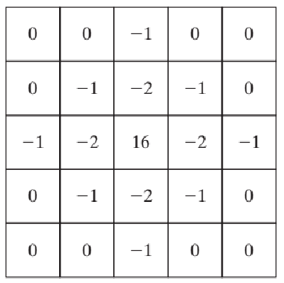

The negative of this mask would be used in practice.

**Results (including pictures):**

Source:



result:

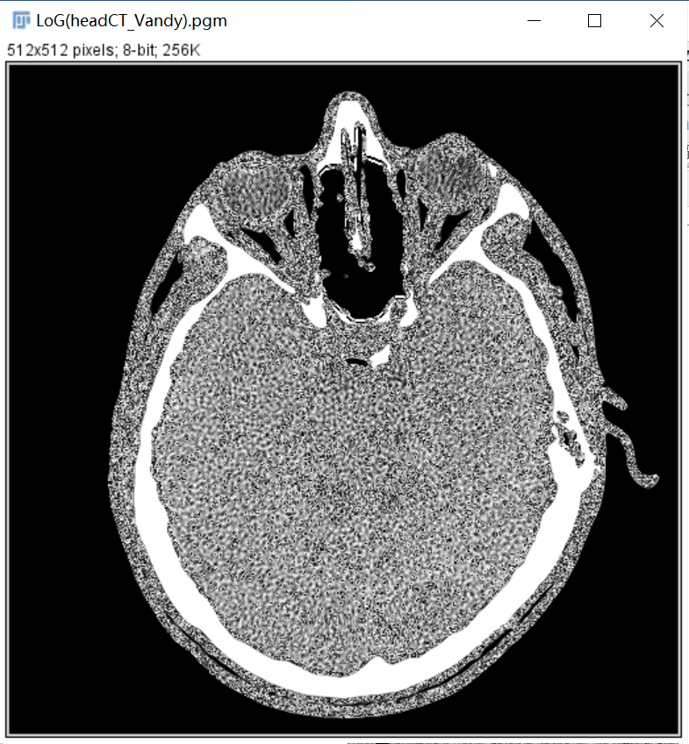

Source:



Result:

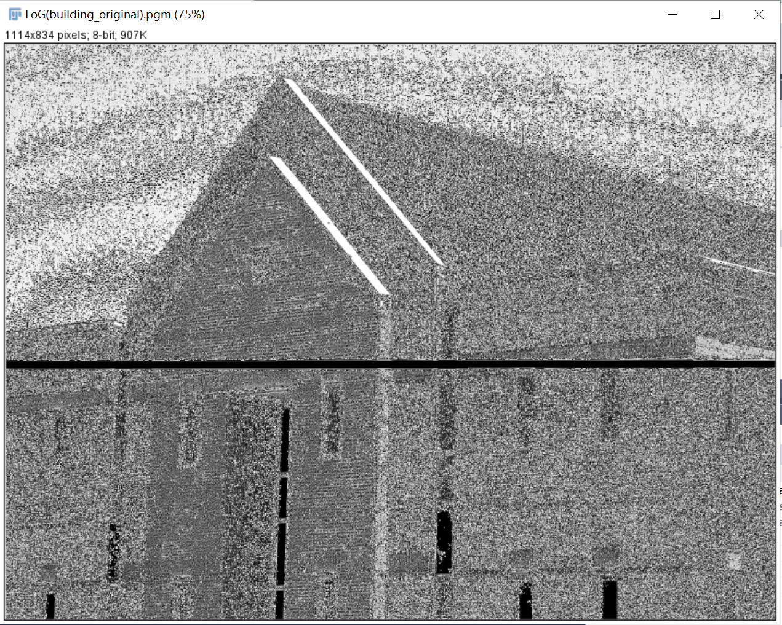

**Discussion:**

The LoG filter has the effect to smooth the image first and then to detect the edges, reducing intensity structures and noise.

LOG filter responds to changes of intensity in any mask direction and no multiple tasks for directional filtering. LoG filter corresponds to human vision characterization.

**Codes:**

Image *LoG(Image* image) {

int width, height;

width = image->Width;

height = image->Height;

Image* outimage;

unsigned char* tempin, *tempout;

const char* comment = "Sobel";

outimage = CreateNewImage(image, comment);

tempin = image->data;

tempout = outimage->data;

for (int i = 2; i < height - 2; i++){

for (int j = 2; j < width - 2; j++){

tempout[i*width + j] = tempin[(i - 2)*width + j] + tempin[(i - 1)*width + j - 1] + 2 * tempin[(i - 1)*width + j] + tempin[(i - 1)*width + j + 1] + tempin[i*width + j - 2] + 2 * tempin[i*width + j - 1] - 16 * tempin[i*width + j] + 2 * tempin[i*width + j + 1] + tempin[i*width + j + 1] + tempin[(i + 1)*width + j - 1] + 2 * tempin[(i + 1)*width + j] + 2 * tempin[(i + 1)*width + j + 1] + tempin[(i + 2)*width + j];

}

}return(outimage);

}

1. **global thresholding (polymersomes.pgm, noisy_fingerprint.pgm):**

**Algorithm:**

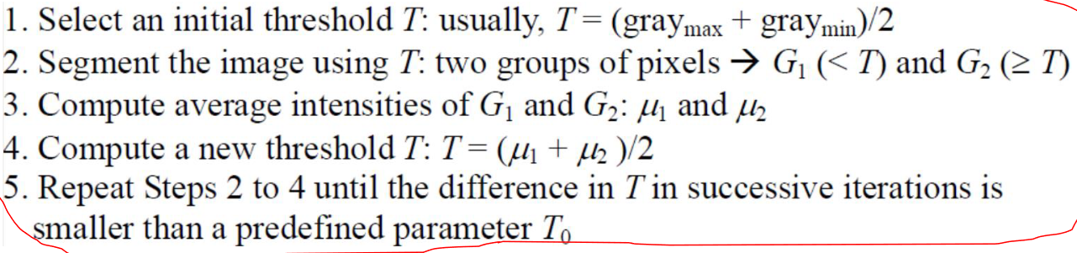

**Results (including pictures):**

Source:

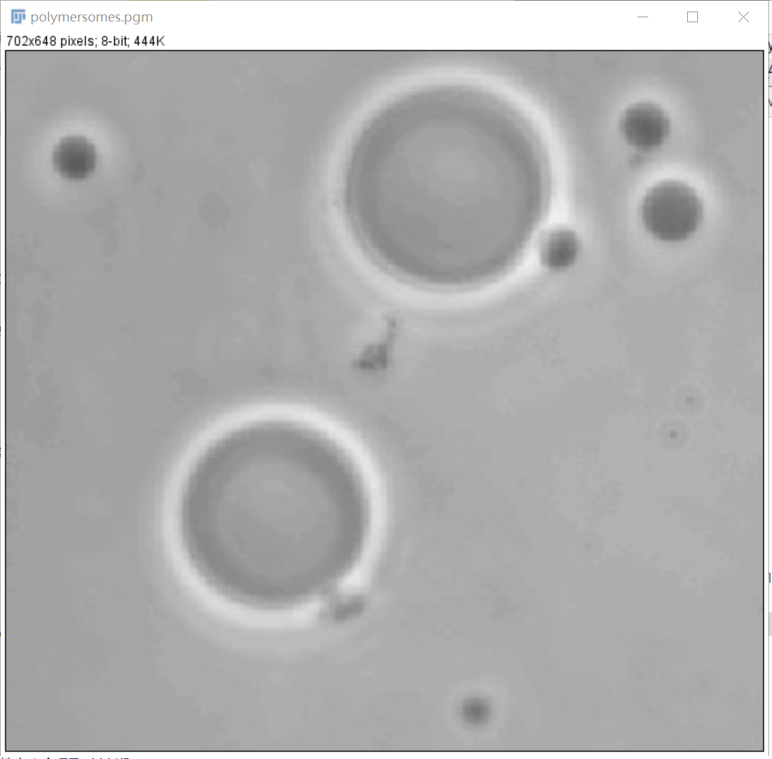

Result:

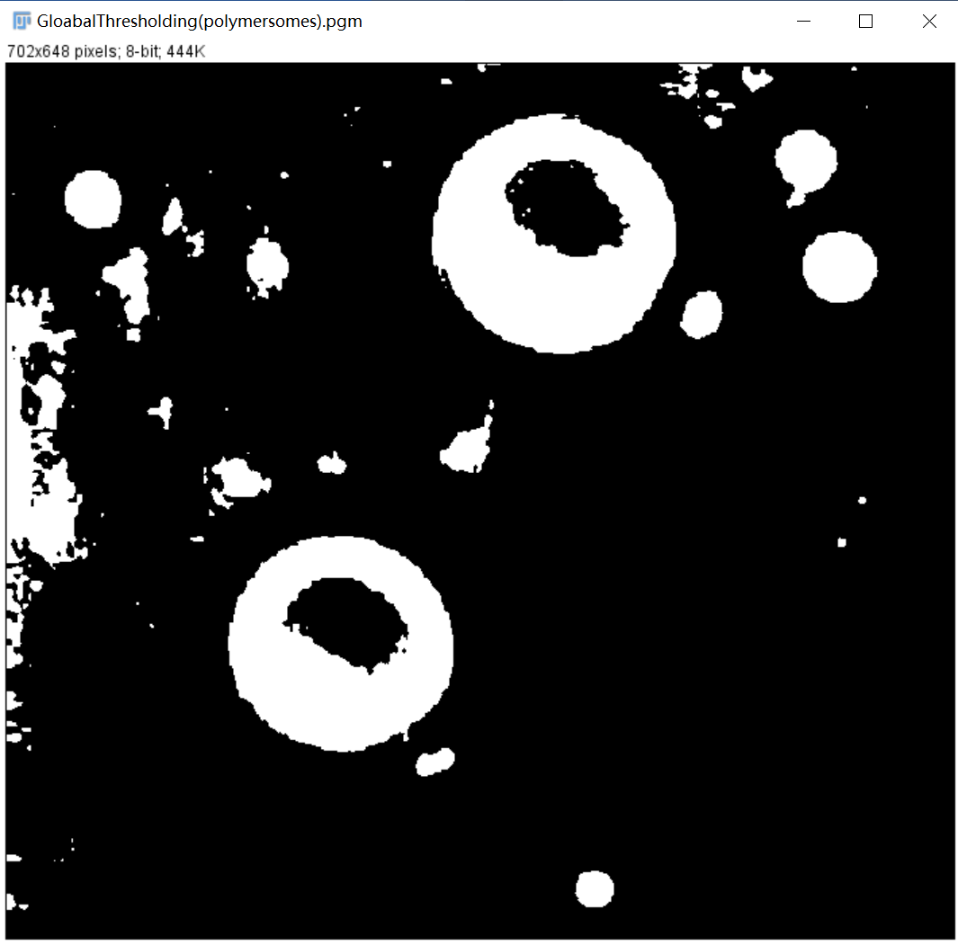

Source: Result:

 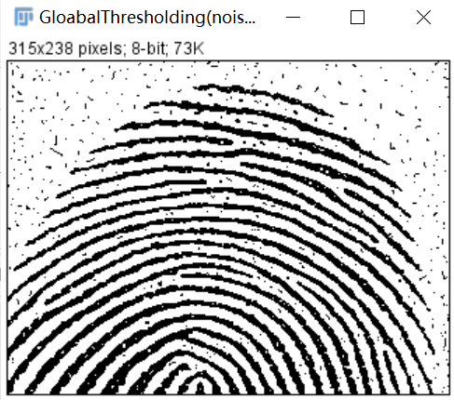

**Discussion:**

This method is much better than histogram method, since you do not need to check the separation level, while automatically generate one.

**Codes:**

Image *GloabalThresholding(Image* image) {

int width, height;

width = image->Width;

height = image->Height;

Image* outimage;

unsigned char* tempin, *tempout;

const char* comment = "GloabalThresholding";

outimage = CreateNewImage(image, comment);

tempin = image->data;

tempout = outimage->data;

int max = 0;

int min = 0;

for (int i = 0; i < height; i++){

for (int j = 0; j < width; j++){

if (tempin[i*width + j] >= max){

max = tempin[i*width + j];

}

if (tempin[i*width + j] <= min){

min = tempin[i*width + j];

}

}

}

float T = (max + min) / 2;

float μ1 = 0, μ2 = 0;

int count1 = 0, count2 = 0, delt_t = 0;

bool judge = false;

while (!judge){

μ1 = 0;

μ2 = 0;

count1 = 0;

count2 = 0;

for (int i = 0; i < height; i++){

for (int j = 0; j < width; j++){

if (tempin[i*width + j] > T){

μ1 += tempin[i*width + j];

count1++;

}

else{

μ2 += tempin[i*width + j];

count2++;

}

}

}

if (count1 != 0){

μ1 /= count1;

}

if (count2 != 0){

μ2 /= count2;

}

judge = abs(T - (μ1 + μ2) / 2) < 0.5;

T = (μ1 + μ2) / 2;

}

for (int i = 0; i < height; i++){

for (int j = 0; j < width; j++){

if (tempin[i*width + j] <= T){

tempout[i*width + j] = 255;

}

else{

tempout[i*width + j] = 0;

}

}

}return(outimage);

}